®

CAMTEL 2022 INTERCONNECTION, ACCESS, AND INFRASTRUCTURE-SHARING CATALOGUE
FOR THE FIXED-LINE LICENCE

OFFER FOR LICENSED OPERATORS

CONTENT
INTRODUCTION 7
I. SWITCHED TRAFFIC ROUTING SERVICE 8
I.1. Description of Points of Interconnection 8
I.1.1. Locations and Types of Signals 8
I.2. Technical Terms 8
I.2.1. Switched Traffic Routing Service 8
I.2.2. Direct Interconnection Offer 8
I.2.3. Indirect Interconnection Offer 8
I.2.4. National Transit Interconnection Offer 8
I.2.5 Incoming or Outgoing International Transit Offer 9
I.2.6. Evolution of Offer 9
I.2.7. Organisation of Interconnection Links 9
I.2.8. Responsibility for Sizing of Links 9
I.3. Switched Traffic Routing Rates 9
I.3.1. National Voice Rate 9
I.3.2. Numbering Format 9
II. LEASING OF TRANSMISSION SERVICES 10
II.1. Description and Technical Terms 10
II.2. Local Leased Line 10
II.2.1. Access Costs: 10
II.2.2. Monthly Charge 10
III. ADDITIONAL SERVICES AND FUNCTIONALITIES 11
III.1. Description, Types of Services, and Technical Terms 11
III.1.1. Description and Technical Terms 11
III.1.2. Types 11
III.2. Pricing 11
IV. DESCRIPTION OF INTERFACES AND INTERCONNECTION SIGNALLING PROTOCOLS 12
IV.1. Electrical Interfaces 12
IV.2. Signalling Protocols 12
V. COLOCATION AND INFRASTRUCTURE SHARING 12
V.1. Colocation and Sharing Offer 12
V.1.1. Technical Terms for Colocation 12
V.1.2. Terminal Equipment Hosting 12
V.1.3. Power Supply 13
V.2. Colocation Rates 13
VI. MAXIMUM TIME-LIMITS FOR THE COMMISSIONING OF THE INTERCONNECTION 13
VII. SCHEDULING OF OPENING OF NEW POINTS OF INTERCONNECTION 14

DEFINITIONS

For the purposes of this catalogue, the terms hereunder shall have the following definitions:

- SRC: Self-contained Routing Centre
- Colocation: provision of space and technical resources required to host and connect, under reasonable conditions, the relevant equipment of an operator as part of a reference offer.
- ITC: International Transit Centre
- NTC: National Transit Centre
- RTC: Regional Transit Centre
- Terminal equipment: any device, installation or set of installations meant to be connected to a network termination point, and which transmits, receives or processes electronic communications signals. This does not include equipment that enables access to audio-visual communication services broadcast over the air or distributed by cable, except where such equipment also enables access to other electronic communications services.
- Certification: Expert assessment and verification exercise conducted by an approved body to certify that the prototype of electronic communications equipment and systems complies with the regulations and technical specifications in force.
- Interconnection: particular method of access that involves physically and logically linking the public electronic communications networks used by the same or different operators to allow users to communicate with each other or to access services provided by another operator;
- Direct Interconnection: CAMTEL routes traffic originating from a customer of the PECNO from the point of interconnection to CAMTEL’s network up to one of its subscribers (CAMTEL subscriber) serviced by or available via its network;
- Indirect Interconnection: CAMTEL carries the traffic of a subscriber on its network to the point of interconnection to a PECNO’s network so that the said subscriber can use the services of the PECNO in question;
- Transit interconnection: two PECNOs interconnect their networks using CAMTEL’s network;
- Terminal equipment interoperability: the ability of terminal equipment to work with the network and with other terminal equipment that enable access to the same service;
- Radio installation, station or equipment: any electronic communication installation, station or equipment that uses radio frequencies for wave propagation in free space. Radio installations notably include networks that use satellite capacities;
- PCM: Pulse-Code Modulation
- Operator: a person or legal entity operating a public electronic communications network or providing an electronic communications service to the public;
- PECNO: Public Electronic Communications Network Operator.
- Termination point: physical point through which users access a public electronic communications network. These connection points are part of the network;
- When a telecommunication network is connected to a foreign network, the points of connection to that network are considered as termination points.
- When a telecommunication network is intended to transmit signals to broadcasting installations, the points of connection to these installations are considered as termination points.
- PION: Point of Interconnection of Operator Networks.
- Public electronic communications network: a set of electronic communications networks established or used to service the needs of the public;
- Electronic communications network: active or passive transmission systems and, where applicable, switching and routing equipment and other resources, which make it possible to transmit signals by wire, by radio, by optical means or by other electromagnetic means: including satellite networks; fixed (circuit- or packet-switched, including the Internet) and mobile terrestrial networks; systems using the electrical network, provided they are used for transmitting signals; networks used for radio and television broadcasting; and cable television networks, irrespective of the type of information broadcast;
- Value-added service: service offered to the public over public electronic communications networks using computer systems providing access to data pertaining to specific areas to consult or exchange them;
- Data transmission service: simple data transmission service that does not include any additional processing;
- Basic telecommunications service: international, national and local telecommunications service for electronic communications between fixed points, facsimile, telex and telegraph.
- Electronic communications service: service consisting wholly or mainly in the provision of electronic communications;
- Additional services and functionalities: Minimum electronic communications service provided at an interconnection interface between CAMTEL’s network and that of a third party.
- STMx: Synchronous Transport Module or optical fibre Synchronous Digital Hierarchy (SDH) network transmission standard, which is a set of protocols for high-speed digital data transmission.
- Global Mobile Personal Communication by Satellite (GMPCS): any existing or planned fixed or mobile, broadband or narrowband, global or regional, geostationary or non-geostationary satellite system providing electronic communications services directly or indirectly to end users via a constellation of satellites;
- Telecommunications: any transmission, emission or reception of signs and signals, text, images, sounds or intelligence of any kind, by wire, optical, radio means or any other electromagnetic system.

INTRODUCTION

This catalogue is published by Cameroon Telecommunications (CAMTEL) in implementation of the Concession Agreement No. 2 of 4 March 2020 for the development and operation of a nationwide fixed-line public electronic communications network, and in accordance with the provisions of Law No. 2010/013 of 21 December 2010 governing electronic communications in Cameroon, as amended and supplemented by Law No. 2015/006 of 20 April 2015, Decree No. 2012/1640/PM of 14 June 2012 to lay down conditions for interconnection, access to public electronic communications networks, and infrastructure sharing, Decree No. 2017/2580/PM of 6 April 2017 to lay down conditions for the establishment or operation and supply of electronic communications services subject to the regime of authorisation, and with Decision No. 44/ART/DG/DLCI/CI of 23 July 2002 to prescribe directives on the conditions for interconnection of public telecommunications networks.
It is valid for 2022.
This catalogue presents CAMTEL’s technical offering and tariffs for Public Electronic Communications Network Operators (PECNO) to enable all users of interconnected networks to communicate freely with each other.
It covers the following interconnection offers:
- switched traffic routing service;
- connecting link services;
- additional services and functionalities;
- colocation and infrastructure sharing services.

Each interconnection arrangement with CAMTEL shall be subject to an interconnection agreement describing the technical and financial terms and conditions of the services offered. It is understood that:
- the rates listed in this catalogue are exclusive of tax (TE);
- the access fees for offers or services shall be those in force on the date such offers or services are made available.
- The rates are set according to traffic volume.
- The services covered by this catalogue are offered within the limits of the technical conditions and capacities of CAMTEL’s infrastructure.

I. SWITCHED TRAFFIC ROUTING SERVICE

I.1. Description of Points of Interconnection

I.1.1. Locations and Types of Signals
The points of interconnection CAMTEL offers to Public Electronic Communications Network Operators are:

Description | Sites | Type of Signal | Type of Interconnection
NTC  Yaounde | CAMTEL building  Yaounde, Centre | Code No. 7 ISUP | National and International Transit
NTC  DOUALA | CAMTEL building  Douala-Bepanda | Code No. 7 ISUP | National and International Transit
ITC  Yaounde | Technical Building  CAMTEL Head Office: | Code No. 7 ISUP/IP | International Transit
ITC  DOUALA | CAMTEL building  Douala-Bepanda | Code No. 7 ISUP/IP | International Transit

I.2. Technical Terms

I.2.1. Switched Traffic Routing Service
The technical connection offer presented in this catalogue makes it possible to deliver voice and data communications from or to PECNOs under the same conditions of quality and technical availability as for all calls made on CAMTEL’s network.
All of this traffic is brought by the PECNO to a point of interconnection of operator networks (PION) and distributed over one or two links of circuits operated on a load-sharing basis. These links must be carried by 2Mbit/s links. Where the traffic is carried by two separate links, the 2Mbit/s links must be separate.

I.2.2. Direct Interconnection Offer
CAMTEL routes traffic originating from a customer of the PECNO from the point of interconnection to CAMTEL’s network up to one of its subscribers (CAMTEL subscriber) serviced by or available via its network.

I.2.3. Indirect Interconnection Offer
CAMTEL carries the traffic of a subscriber on its network to the point of interconnection to a PECNO’s network so that the said subscriber can use the services of the PECNO in question.

I.2.4. National Transit Interconnection Offer
A PECNO routes its national traffic via CAMTEL’s network to another PECNO.

I.2.5 Incoming or Outgoing International Transit Offer
The incoming or outgoing international transit offer enables CAMTEL to route international traffic to or from other PECNOs.

I.2.6. Evolution of Offer
CAMTEL frequently redevelops areas serviced by subscriber switches.
The list of numbers accessible from the transit switches of a PION varies over time. CAMTEL will inform the TRB and PECNO in advance of any redevelopment of transit areas.
Some switches originally open for interconnection may, in the short or medium term, cease to be operational or be subject to technical limitations. CAMTEL will inform the TRB and PECNOs of the closure of such switches or of their technical limits in accordance with regulatory provisions.
CAMTEL may:
- redevelop the areas served by PIONs;
- modify the number of PIONs.
CAMTEL will inform the TRB and PECNOs of this in accordance with regulatory provisions.

I.2.7. Organisation of Interconnection Links
The connection capacity is defined for each PION to which the operator wishes to connect.
The basic unit is the 2Mbps link.
The mode chosen for interconnection with CAMTEL’s network is the bidirectional link operating mode.

I.2.8. Responsibility for Sizing of Links
A PECNO interconnecting to CAMTEL’s network shall be responsible for the sizing of the interconnection links needed to deliver its traffic to CAMTEL’s network.
Similarly, CAMTEL shall be responsible for the sizing of its links towards the PECNO.
The opening of a link with a PECNO shall be preceded by a series of validation and compatibility tests in accordance with the provisions of the interconnection agreement and regulations relating to the routing of calls to emergency, security and police services.

I.3. Switched Traffic Routing Rates

I.3.1. National Voice Rate
TYPE OF ACCESS | Peak Hour Rates  (7 am-8:59 pm) | Off-peak Hour Rates  (9 pm to 6:59 am)
Access to the transit centre | CFAF 12, tax excluded | CFAF 10, tax excluded

I.3.2. Numbering Format
CAMTEL’s numbering plan follows the following format: 2XX XX XX.

II. LEASING OF TRANSMISSION SERVICES

II.1. Description and Technical Terms
For any PECNO, CAMTEL offers a connecting link to a PION. The connecting link is the means of transmission that enables a PECNO to deliver its interconnection traffic to a PION. CAMTEL guarantees a quality of service identical to that of its network on the connecting link.

II.2. Local Leased Line
CAMTEL offers an urban leased line that enables PECNOs to interconnect their equipment within the same urban area. They are implemented via cable.

II.2.1. Access Costs:
THROUGHPUT | 2 Mbps | 34 Mbps | 45 Mbps | STM1 | STM4 | STM16 | STM64 or more
COST (in CFAF, T.E.) | 2,000,000 | 3,000,000 | 3,000,000 | 3,500,000 | 4,000,000 | 5,000,000 | 6,000,000

II.2.2. Monthly Charge
Fixed cost: CFAF 50 000 (T.E.)/month;
The monthly fee is based on the distance between the nearest CAMTEL Transmission Centre, and the PECNO’s remote site.

Throughput (Mbps) | The monthly flat rate in CFAF (TE) for a distance ≤ 5 KM | The monthly flat rate in CFAF (TE) for a distance > 5 km
2 | 24,239 | 25,327
6 | 54,342 | 62,595
10 | 67,370 | 67,370
20 | 110,962 | 130,488
34 | 130,961 | 168,025
45 | 140,845 | 180,997
75 | 188,204 | 242,623
100 | 213,317 | 275,359
155 | 249,566 | 323,695
622 | 811,089 | 1,052,006
1024 | 1,482,592 | 1,922,965
STM16 | 3,041,584 | 3,945,024
STM64 | 7,299,801 | 9,468,059
The commercial offer for throughputs above STM64, established following specific requests, will be detailed in interconnection agreements.

III. ADDITIONAL SERVICES AND FUNCTIONALITIES
The minimum service provided at an interconnection interface between CAMTEL’s network and that of the PECNO is the electronic communications service.

III.1. Description, Types of Services, and Technical Terms

III.1.1. Description and Technical Terms
For communications with other networks, the implementation of functionalities depends on the level of quality and services offered by the remote operator. CAMTEL cannot make any commitments beyond what it currently offers its own clients.
As concerns responsibility for the sizing of links, each operator shall be responsible for the sizing of the interconnection links needed to transport its own traffic. An operator interconnecting to CAMTEL’s network shall be responsible for the sizing of the interconnection links delivering:
- direct interconnection traffic;
- indirect interconnection traffic.
The use of certain parameters shall be subject to operating rules at the level of the interface. They must be established by mutual agreement between CAMTEL and third-party operators.

III.1.2. Types

Special numbers
The technical and pricing terms for special numbers for value-added services, accessible by other operators, shall be defined in interconnection agreements, in accordance with the regulatory provisions in force.
Emergency call services
CAMTEL take steps to route emergency calls from the interconnection points to the services responsible for:
- the protection of human lives;
- the intervention of public security forces;
- firefighting;
- urgent social issues;
- public interest.

III.2. Pricing
Taking into account the specific needs of each customer, the pricing conditions applicable to additional services and functionalities will be detailed in interconnection agreements.

IV. DESCRIPTION OF INTERFACES AND INTERCONNECTION SIGNALLING PROTOCOLS

IV.1. Electrical Interfaces
The connecting link shall consist of a set of 2Mbps links. The connection interface complies with ITU-T recommendation G.703, CEPT 2Mbit/s, 120 Wsymmetrical.
Warning, signalling, fault location and intervention procedures are defined in the interconnection agreement between CAMTEL and PECNO.

IV.2. Signalling Protocols
The signalling protocol to be used for the interconnection of the PECNO will be signalling system No. 7 ISUP (ITU-T Recommendation No. Q.761-Q.764 1992 Specifications of ISDN User Part) in the NITC in Yaounde and in Douala.
The opening of a link with a PECNO shall be preceded by a series of validation and compatibility tests in accordance with the regulatory provisions and the interconnection agreement.

V. COLOCATION AND INFRASTRUCTURE SHARING

V.1. Colocation and Sharing Offer

V.1.1. Technical Terms for Colocation
CAMTEL shall offer the colocation service to PECNOs that want to implement the interconnection link themselves. Where the equipment is located on its premises, CAMTEL shall be notified of any intervention thereupon.
To implement an interconnection, link up to a point of interconnection (PION), a PECNO may use CAMTEL’s infrastructure, within the limits of the site’s available hosting capacities (land, power supply, building, conduits, etc.), to install the transmission link’s support.
Where possible, the terminal equipment used for transmission may be installed in a room reserved for the PECNO and located in CAMTEL’s building or in a room built by the PECNO on CAMTEL’s site. In both cases, the PECNO shall be responsible for the operation and maintenance of their equipment. The connection of the PECNO’s equipment to PCM distribution frame of the PION shall be implemented by a joint CAMTEL/PECNO team.

V.1.2. Terminal Equipment Hosting
In exceptional cases, terminal equipment used for transmission may be installed in a CAMTEL transmission room. The said equipment must be installed in a watertight cabinet that may also contain the secondary power supply equipment and air conditioning. CAMTEL may, under terms to be negotiated, handle the first level operation and maintenance of the equipment housed in its rooms. In the sites (PION) where colocation is possible, the minimum throughput required is 4 times 2Mbps and demultiplexing at 2Mbps at the level of access remains the responsibility of the PECNO.

Terms of Access
The terms under which the PECNO shall access the room where their equipment is installed shall be specified in the interconnection agreement.

V.1.3. Power Supply
The infrastructure sharing agreement shall specify the terms for the PECNO by CAMTEL, the terms of access to the equipment, the terms and conditions of maintenance, the documentation, the material to be provided by the PECNO and additional services.

V.2. Colocation Rates
NATURE OF SERVICE | RATE in CFAF, T.E.
Use of a CAMTEL chamber | Based on estimate.
Use of CAMTEL ducts (penetration into a cell) | Based on estimate.
Installation, cable, cabling and testing | Based on estimate.  (cost of equipment + hour-based services)
Land | On basis of a cost estimate according to regions, price per m2, surface area required (surveys, surveys, miscellaneous research).  Undeveloped land:  - Yaounde, Douala, Kribi, Limbe: CFAF 7,000/m2/yr  - Other towns: CFAF 5,000/m2/yr  - Rural areas: CFAF 3,000/m2/yr
Building | DOUALA, YAOUNDE, KRIBI, LIMBE: CFAF 90,000/m2/yr  Other urban areas: CFAF 60,000/m2/yr  Rural areas: CFAF 40,000/m2/yr
Back-up power supply | CFAF 99/KWH/month  + fixed premium of CFAF 2,865/KW/month
Air-conditioning | On the basis of equipment installed and capacity requested.

VI. MAXIMUM TIME-LIMITS FOR THE COMMISSIONING OF THE INTERCONNECTION
Subject to the availability of all interface equipment, the interconnection shall be made available within 30 days of receipt of the request.
As far as colocation is concerned, the feasibility will be communicated to the PECNO within a maximum period of 60 days from receipt of the request for colocation.
The PECNOs and CAMTEL shall set out, in their agreements, the terms and conditions for communicating their traffic volumes.
The time-limit for activation all the numbering resources allocated by the TRB is 5 (five) working days upon receipt of a formal request.

VII. SCHEDULING OF OPENING OF NEW POINTS OF INTERCONNECTION
To ensure planning of the necessary interconnection resources and to guarantee adequate sizing of traffic management capacities within CAMTEL’s network, the terms for planning and scheduling the opening of new point of interconnection may be defined.

NB: The interconnection and access agreement shall comply with interconnection and access catalogues. To this end, the provisions of the catalogues, once approved, will be taken into account in all interconnection agreements signed between CAMTEL and its partners.

ANNEXE 1: SITES OPEN FOR SHARING

All CAMTEL buildings throughout the national territory covered by the fixed network are open to sharing and the applicable rates are those set out under point V.2

ANNEXE 2: NATIONAL OPTICAL FIBRE BACKBONE: LOCAL METROPOLITAN LOOPS
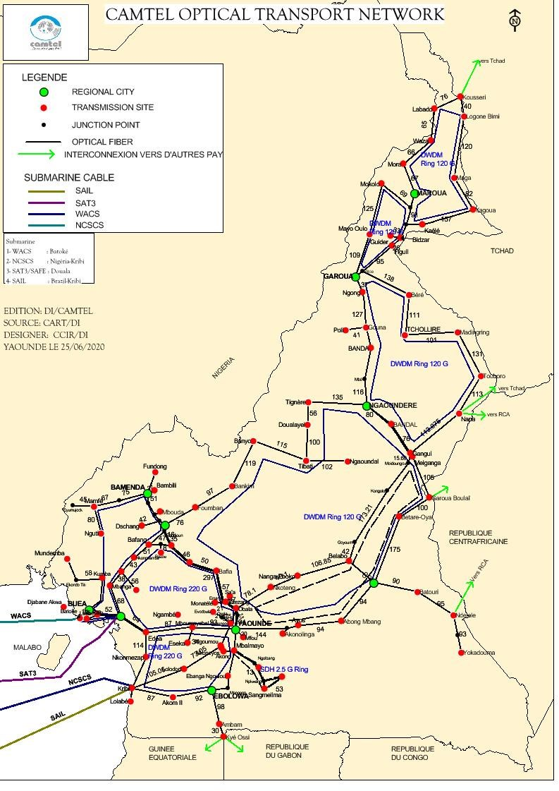
ANNEXE 3: LOCAL METROPOLITAN LOOPS

1. Yaounde
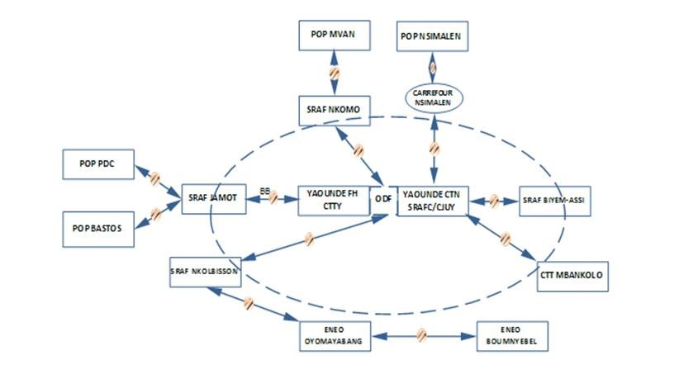
2. Douala
OSN

3500
SAT
3
OSN

7500

BEP
ANDA
OSN

3500

AKWA CENTRE
OSN

3500

BASSA
MINPOSTEL SDH LOOP

10
Gbps

DOUALA
OSN 8800 BASSA OSN 8800 AKWA CENTRE OSN 6800 BEPANDA

3. Maroua
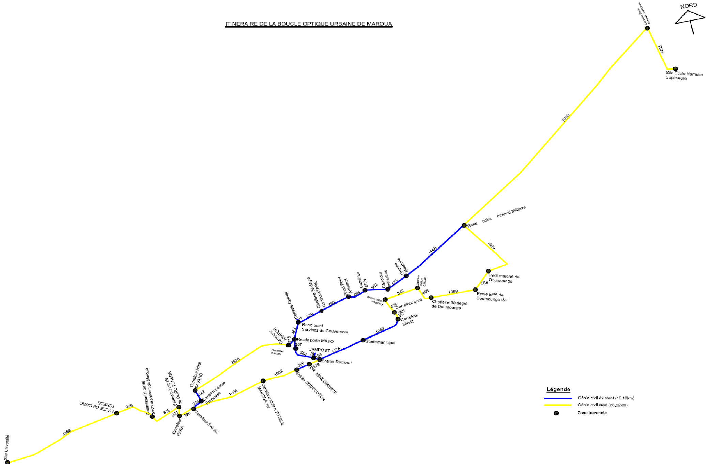

4. Bafoussam
NPT

1200
CAMTEL SWITCH
NTP

1200
2
e CARR
.

EVECHE
Capacity of loop
:

10

GE &

2
.
5

Gbps SDH

5. Ebolowa
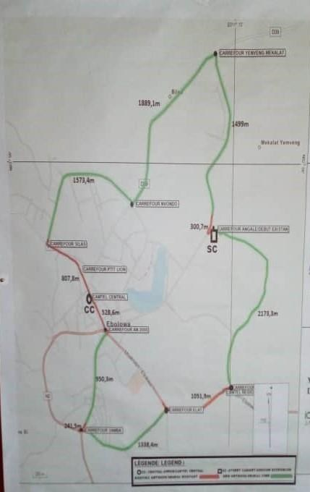

NPT

1200
CAMTEL SWITCH
NTP

1200
EBOLOWA
-
SUB-

DIV

2
e
Capacity of loop
:

10

GE &

2
.
5

Gbps SDH

